1.Show all records of male patients in dataset?

<https://github.com/rushi2828-DA/SQL/blob/main/Lung_cancer.sql>

2.How many male patients are in the dataset?

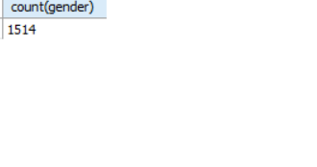

3.Show all records of female patients in dataset?

<https://github.com/rushi2828-DA/SQL/blob/main/Lung_cancer.sql>

4.How many female patients in the dataset?

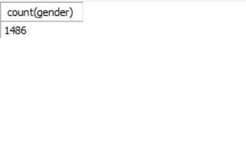

5.Show all records of male patients in dataset?

<https://github.com/rushi2828-DA/SQL/blob/main/Lung_cancer.sql>

6.Show records of male patients who have lung cancer?

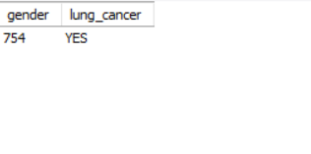

7.Show all records of female patients in dataset?

<https://github.com/rushi2828-DA/SQL/blob/main/Lung_cancer.sql>

8.Show records of female patients who have lung cancer?

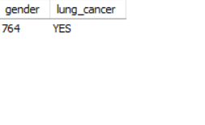

9.What is the total score of patients grouped by lung cancer?

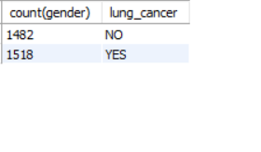

10.How many patients are older than 60?

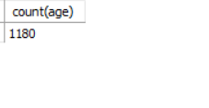

11.How many male patients are older than 60?

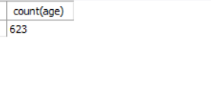

12.Calculate sum of smoking for all patients in dataset?

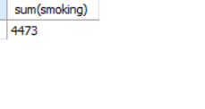

13.Calculate average age of all patients?

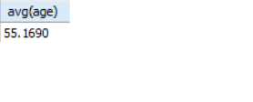

14.What is minimum age of patient in dataset?

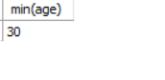

15.What is maximum age of patient in dataset?

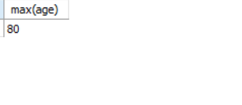

16.How many patients are age between 30 to 60?

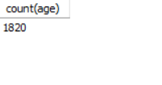

17. What is the average chest pain level for each lung cancer group, where the average is greater than 1?

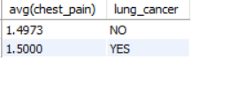

18.Show first 5 records in lung cancer in dataset?

<https://github.com/rushi2828-DA/SQL/blob/main/Lung_cancer.sql>

19.List all unique combinations of gender and chest pain as per level?

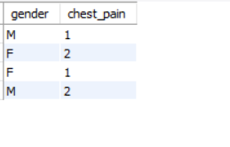

20How many patients who are either 30 or 35 years old?

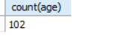

21.Show all patient sorted by ascending order?

<https://github.com/rushi2828-DA/SQL/blob/main/Lung_cancer.sql>

22.Show all patient sorted by descending order?

<https://github.com/rushi2828-DA/SQL/blob/main/Lung_cancer.sql>

23.Show the patients who are 30 years old and have lung cancer?

<https://github.com/rushi2828-DA/SQL/blob/main/Lung_cancer.sql>

24.Show the patients who are chest pain level 2 or they are male?

<https://github.com/rushi2828-DA/SQL/blob/main/Lung_cancer.sql>

25.Retrieve all records of patients who are not male and experiencing chest pain at level 2?

<https://github.com/rushi2828-DA/SQL/blob/main/Lung_cancer.sql>